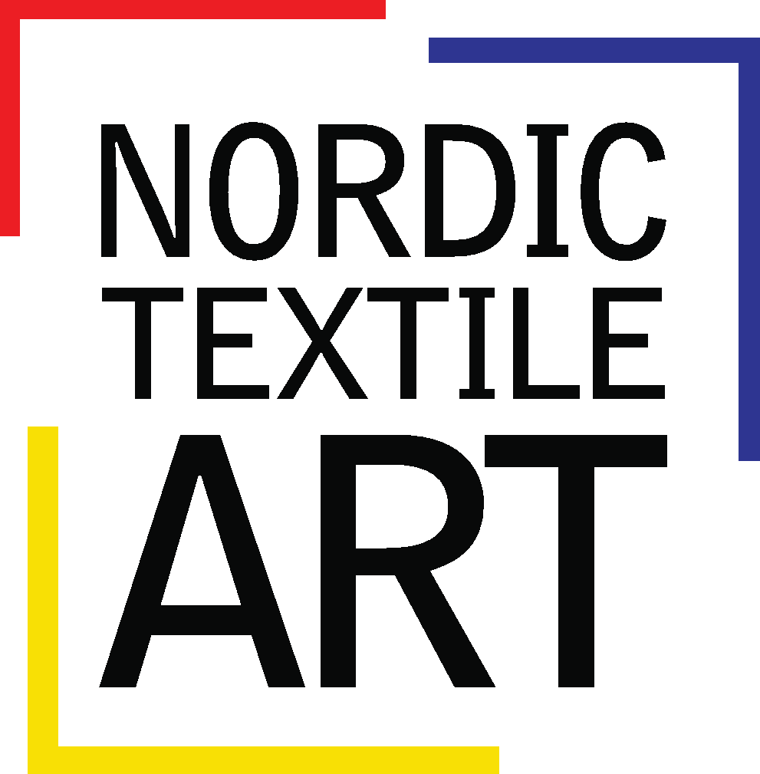

Conference application form page 1

NORDIC TEXTILE MEETING IN HÄMEENLINNA 2018
- TEXTILE IS POWER

First day for registration: December 12th 2017. Last date for registration: February 22th 2018

Please send your registration form by e-mail to info@nordictextileart.net
(you can either scan/take a photo of the PDF with your answers or use the word-doc.)

Conference fees (Please tick the appropriate box)
Basic fee (obligatory for Conference participants)
for NTA members…………………….…………………..……...…………….…...…… ¤ 75 €
for students …………………..………………………………...….…….........................….¤ 30 €
I will become a member of Nordic Textile Art, NTA………………….....…...…….....…...¤ 22 €

Thursday 22.3 (For our information please tick the box)
I will arrive during the day………………………….. ….……….……….….……....…......¤
I will join the dinner in Hämeenlinna (you pay at the restaurant)…………..………….…....¤

Friday 23.3 (For our information please tick the box)
I will join the guided industry tour …………….………..........………….………….…….....¤
I will take part in the Nordic Championship in darkness knitting……………………............¤ 20 €
I will join the dinner at Inkala herrgård (you pay at the restaurant)…………..……….....…...¤

Saturday 24.4
Workshop 1 - Rya - handknuten. Material ingår i priset...……………...…...................…...¤ 80 €
Workshop 2 - Textiltryck – mönster, mönster, mönster Material ingår i priset…...…......¤ 60 €
Workshop 3 - Industriväv. Material ingår i priset.……………………….………...….…...¤ 105 €
Workshop 4 - Lasercut …hemuppgift ges i förväg………...…………………...……........¤ 50 €
Workshop 5 - Broderi och högläsning……………………………………….……...........¤

I will take part of the dinner in Hämeenlinna (you pay at the restaurant)………...…….…....¤

Sunday 25.3

I will take part in the NTA Annual meeting....…………….…………………....……..……..¤

SUMMA att betala…………………………………………………………………………

Sender
Name:……………………………………………………………………………………….
If you are representing an organization/institution:….…..………………………………..…
Country:……………………………………………………………………………………..
Function, occupation………………………………………………………………………...
email…………………………………………………………………………………..……..
Date…………………………………………………………………………………………
To be continued on next page.

Conference application form page 2 Continue from page 1

Payment
I will pay by Paypal directly from my Paypal account via the button 'send money' to your
account. (Recipient´s email: info@nordictextileart.net) ………...………..……… …….…..¤
I will pay by bank transfer to Bg 5890 - 7767.……...…………………………….…………¤
I will pay by bank transfer to Swedbank..…………...………………………….…………...¤

Account: 8214 - 9 924 857 620 - 0
IBAN: SE91 8000 0821 4992 4857 6200
BIC: SWEDSESS
c/o Josabet Werkmäster
Repslagaregatan 10
211 21 Malmö
Sverige

Last date for registration: February 22th 2018. Last day for payment: February 22th 2018
Please send your registration form by e-mail to info@nordictextileart.net or by mail to NTA c/o Josabet Werkmäster, Repslagaregatan 10, 211 21 Malmö, Sweden.
Observera att workshoparna har begräsat antal deltagare förutom Broderi och högläsning. Om den workshop du har anmält dig till ställs in pga av för få anmälda meddelas du senast den 25 februari. Hela avgiften för workshopen betalas i så fall tillbaka.
If you cancel your registration before February 22th the whole conference fee is refunded. Half the fee is refunded if cancelled before March 9th. Cancellations after March 9th, are not refunded.

For further information about registration or payment please contact by mail info@nordictextileart.net: Josabet Werkmäster, treasurer.

First day for registration: December 12th 2017. Last date for registration: February 22th 2018

Please send your registration form by e-mail to info@nordictextileart.net
(you can either scan/take a photo of the PDF with your answers or use the word-doc.)

